Azure DevOps Release Pipeline Revision History

|  |  |  |  |
| --- | --- | --- | --- |
| **Date** | **Version** | **Description of Modifications** | **Updated By** |
| 07/01/2019 | 1.0 | Initial Draft | Elliot Faure Garcia |
|  |  |  |  |
|  |  |  |  |
|  |  |  |  |

Table of Contents

Purpose 4

Assumptions 5

Creating Release Pipeline 6

Configure Artifacts 9

Configure Web Deployment 11

Configure Web API Deployment 16

Manually Run Release 19

Purpose

The purpose of this document is to provide a step by step tutorial on how to create a release pipeline in for a Web Application and API in Azure DevOps.

Assumptions

This documentation assumes that all application settings for each resource in Azure has been configured prior to the deployment.

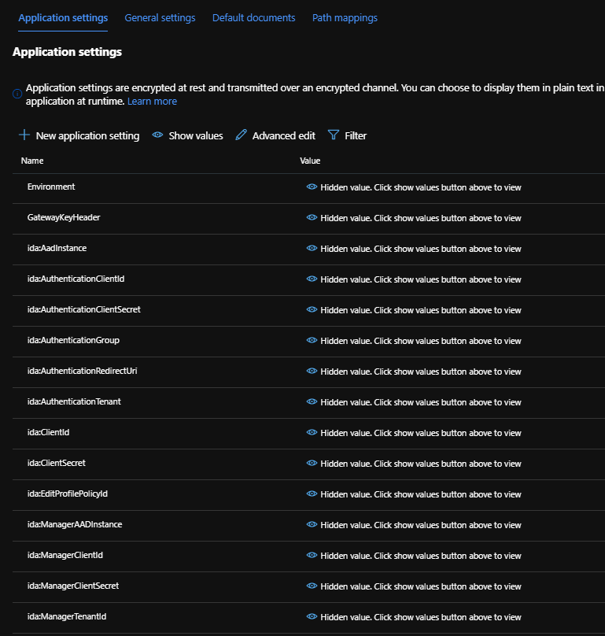

Creating Release Pipeline

1. **Navigate** to <https://meck-tfs.visualstudio.com/>

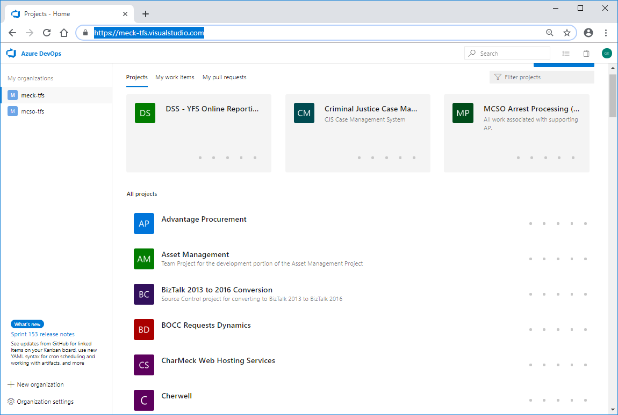

1. **Select** the Project

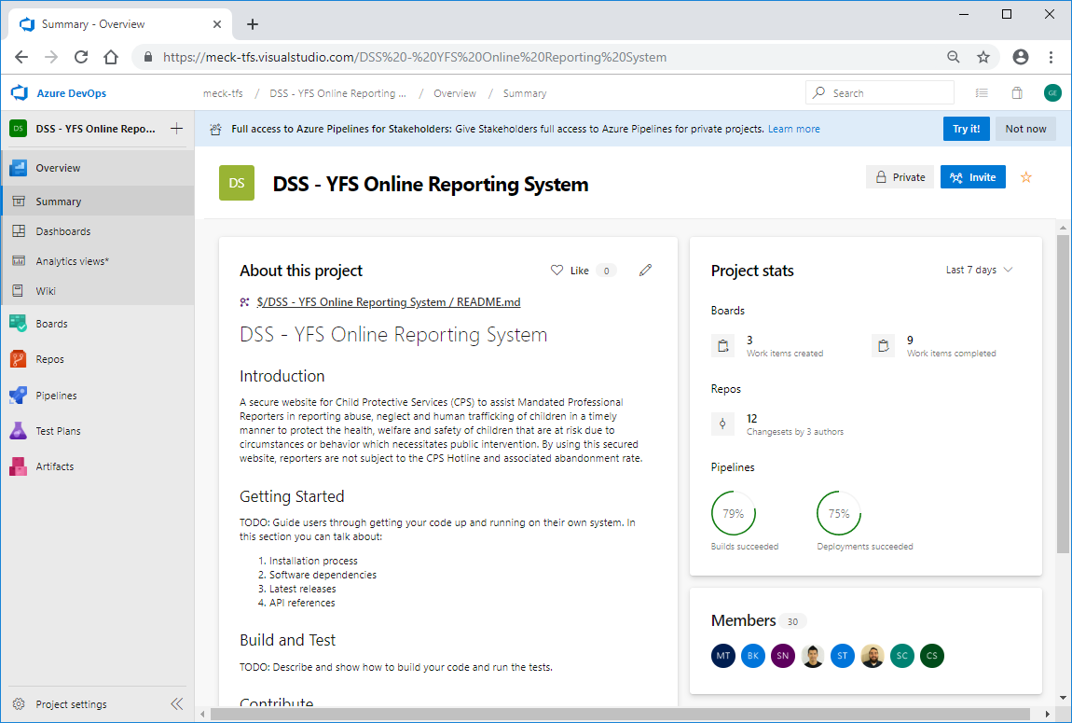

1. **Select** Pipelines and **Select** Releases

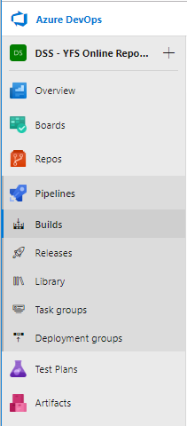

1. **Click** New

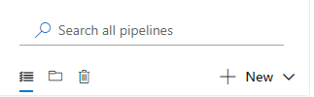

1. **Select ‘**New Release Pipeline’

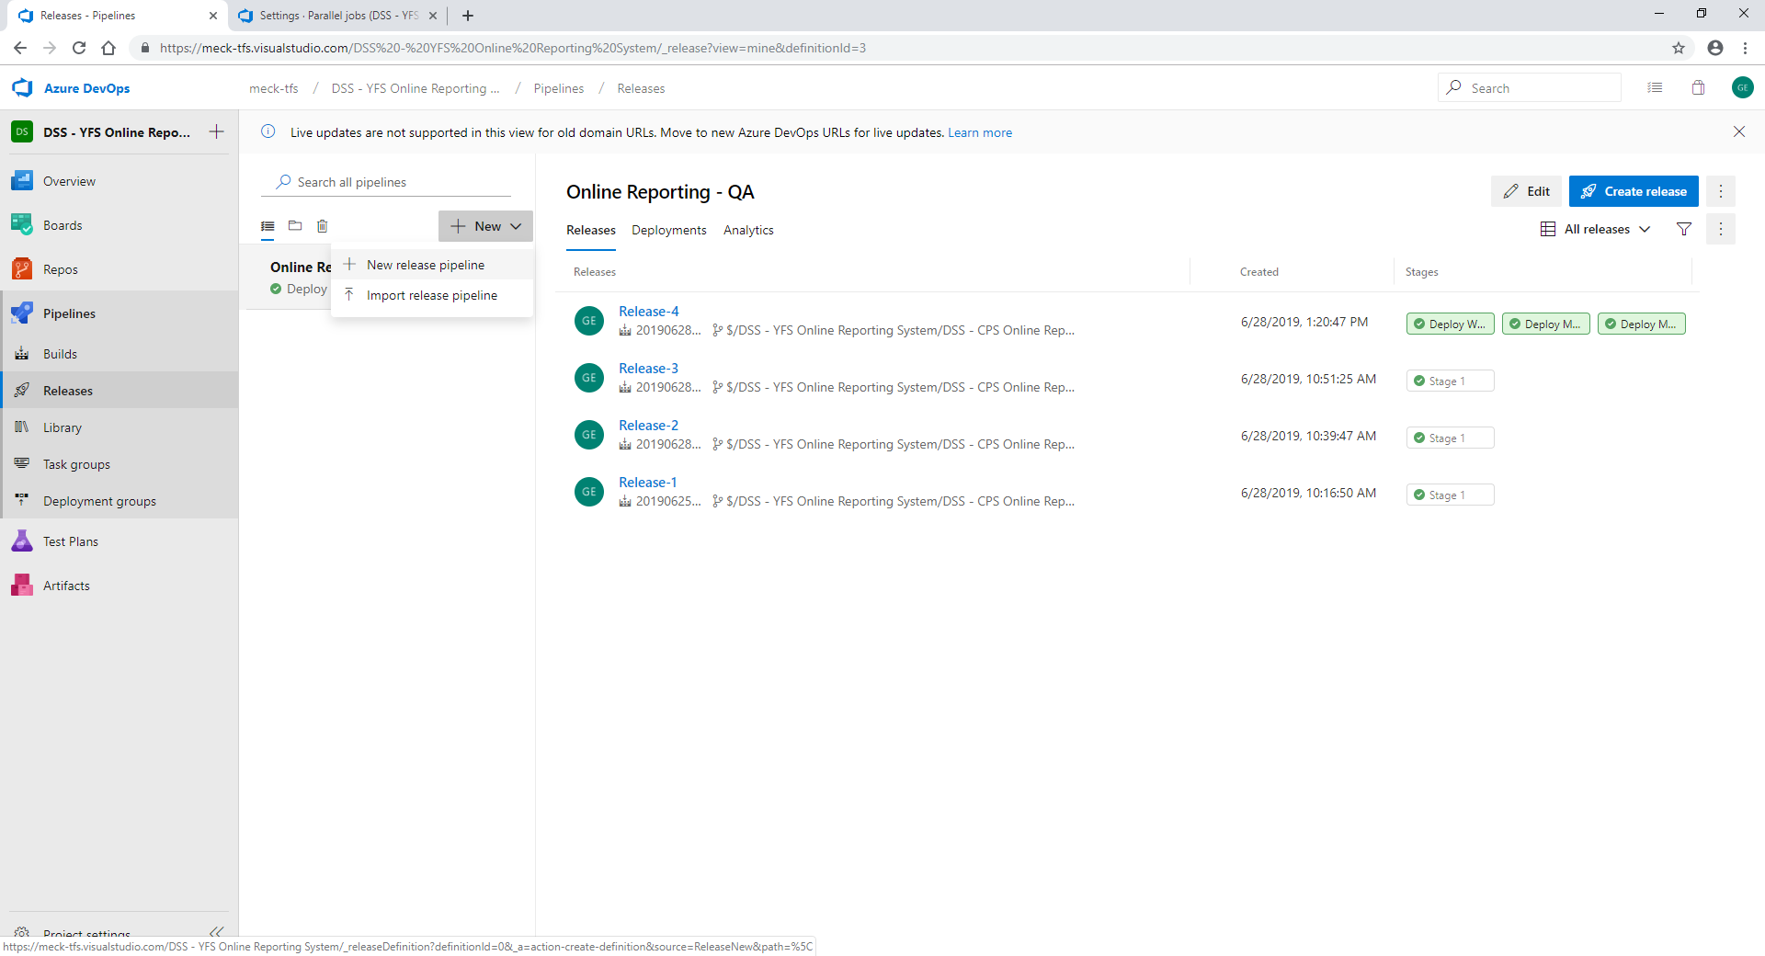

1. **Select** ‘Azure App Service Deployment’
2. **Click** ‘Apply’

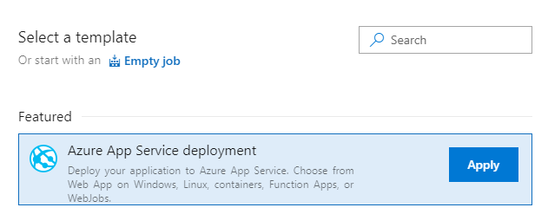

Configure Artifacts

1. **Click** on ‘Add an artifact’

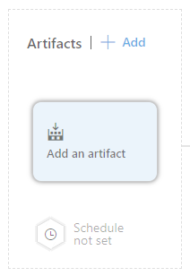

1. **Select** ‘Build’

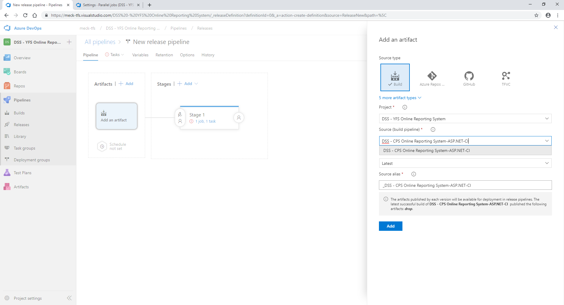

1. **Select** the project
2. **Select** Source
3. **Select** Default version – Latest
4. **Enter** Source alias
5. **Click** Add

Configure Web Deployment

1. **Select** ‘Stage 1’

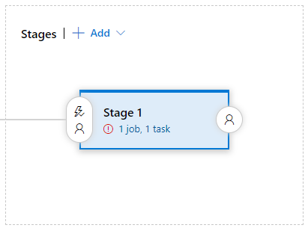

1. **Change** the stage name ‘Deploy Web’

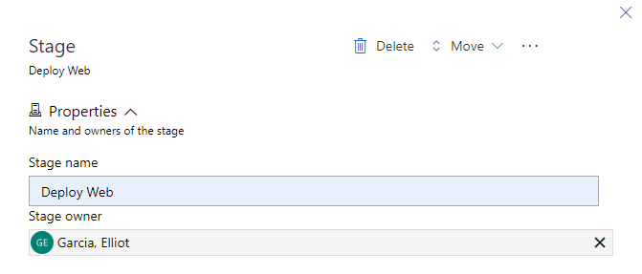

1. **Click** on the stage link ‘1 job, 1 task’

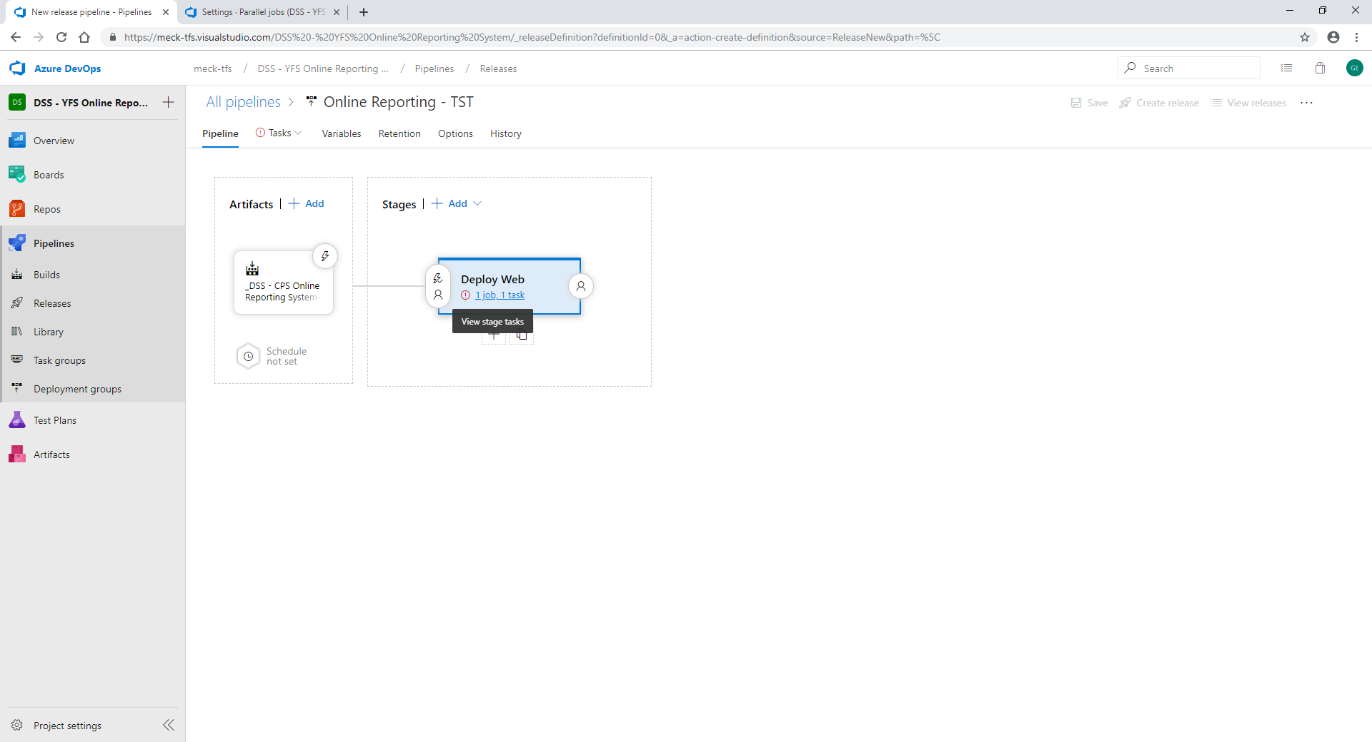

1. **Select** ‘Deploy Web’ step

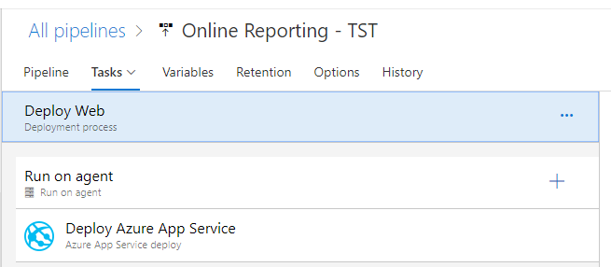

1. **Select** Azure subscription‘MeckProd’ under Azure service connections

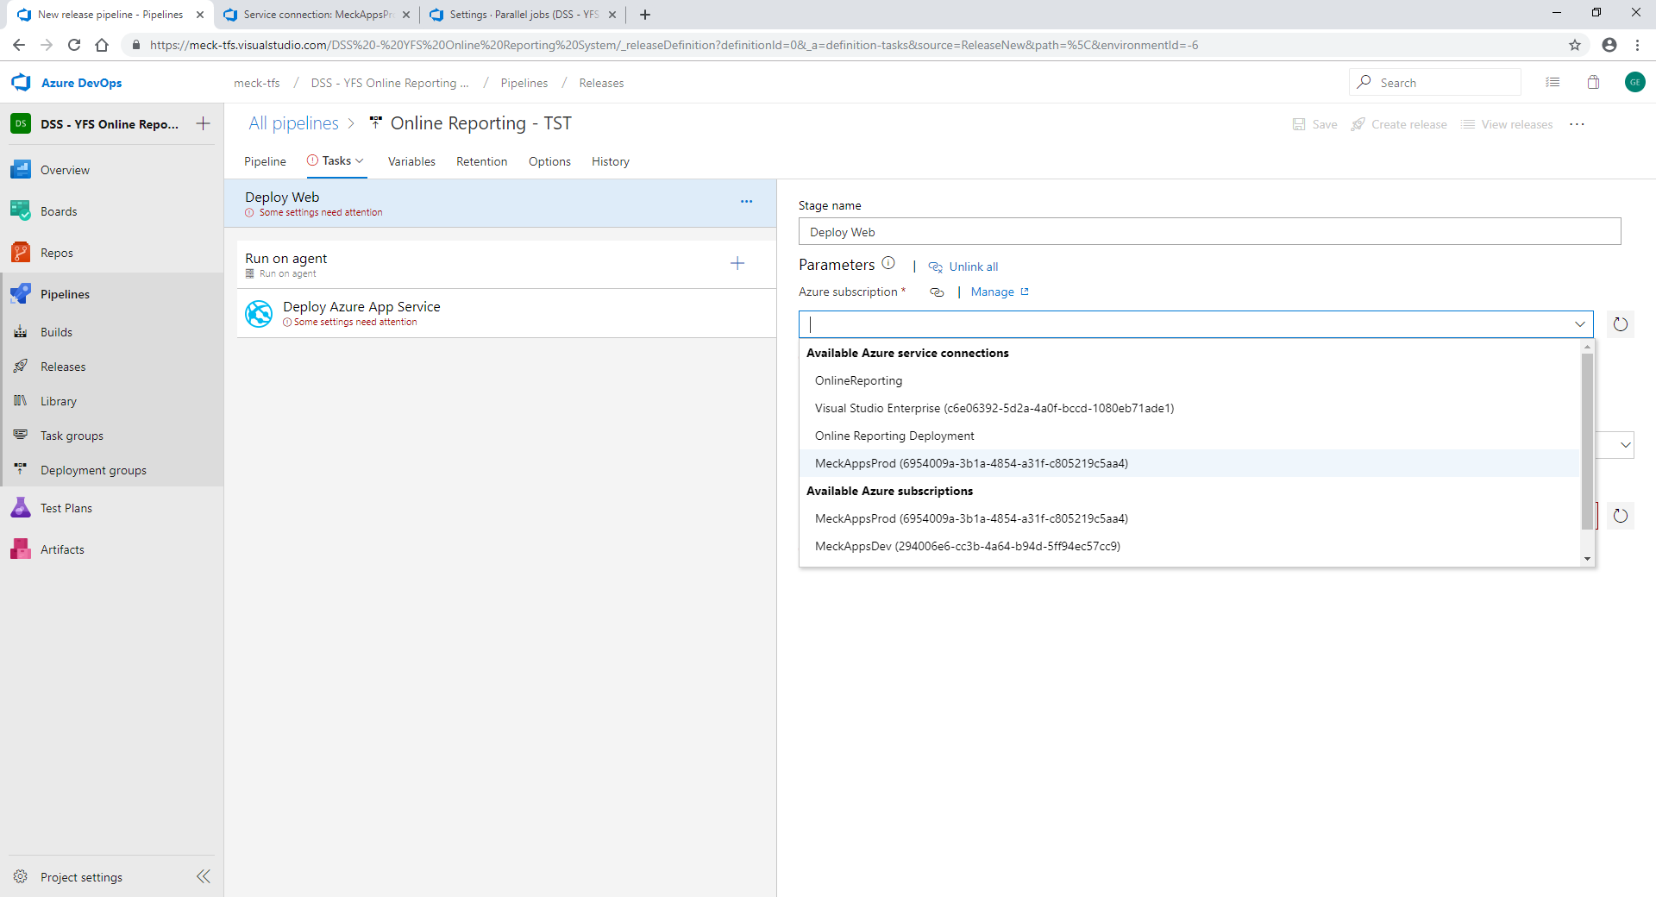

1. **Select** App type ‘Web App on Windows’

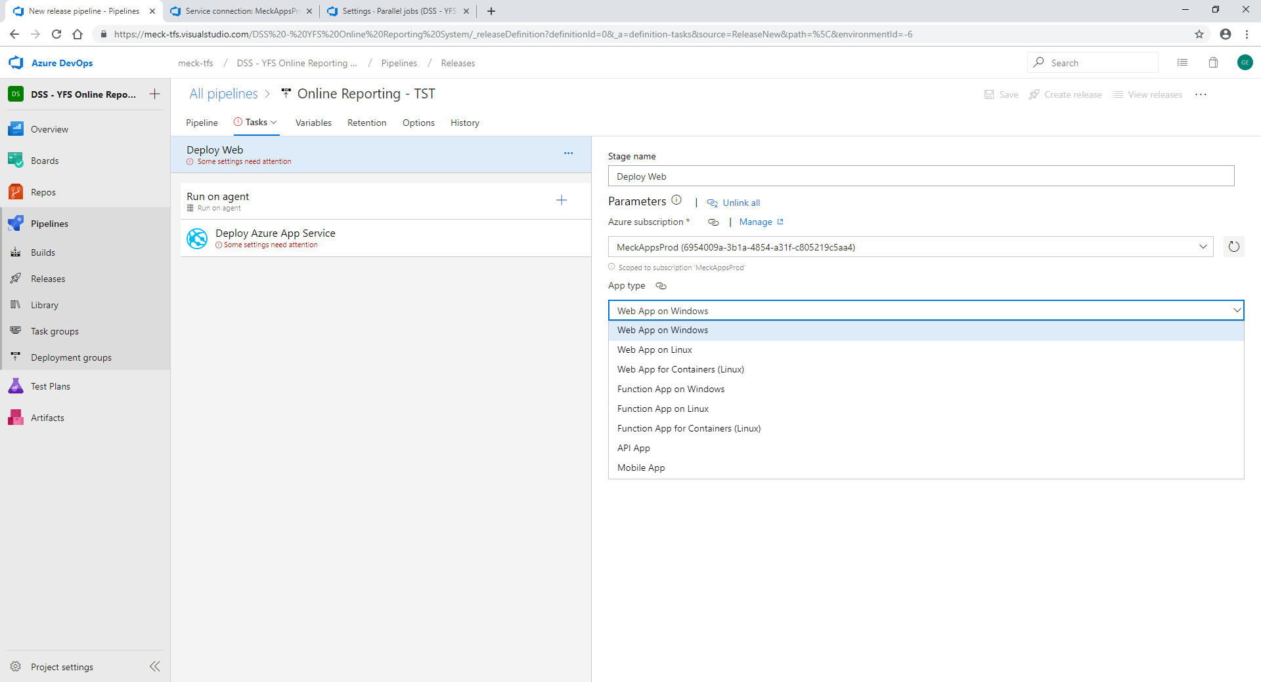

1. **Select** App service name (Should the web app resource you are deploying to)

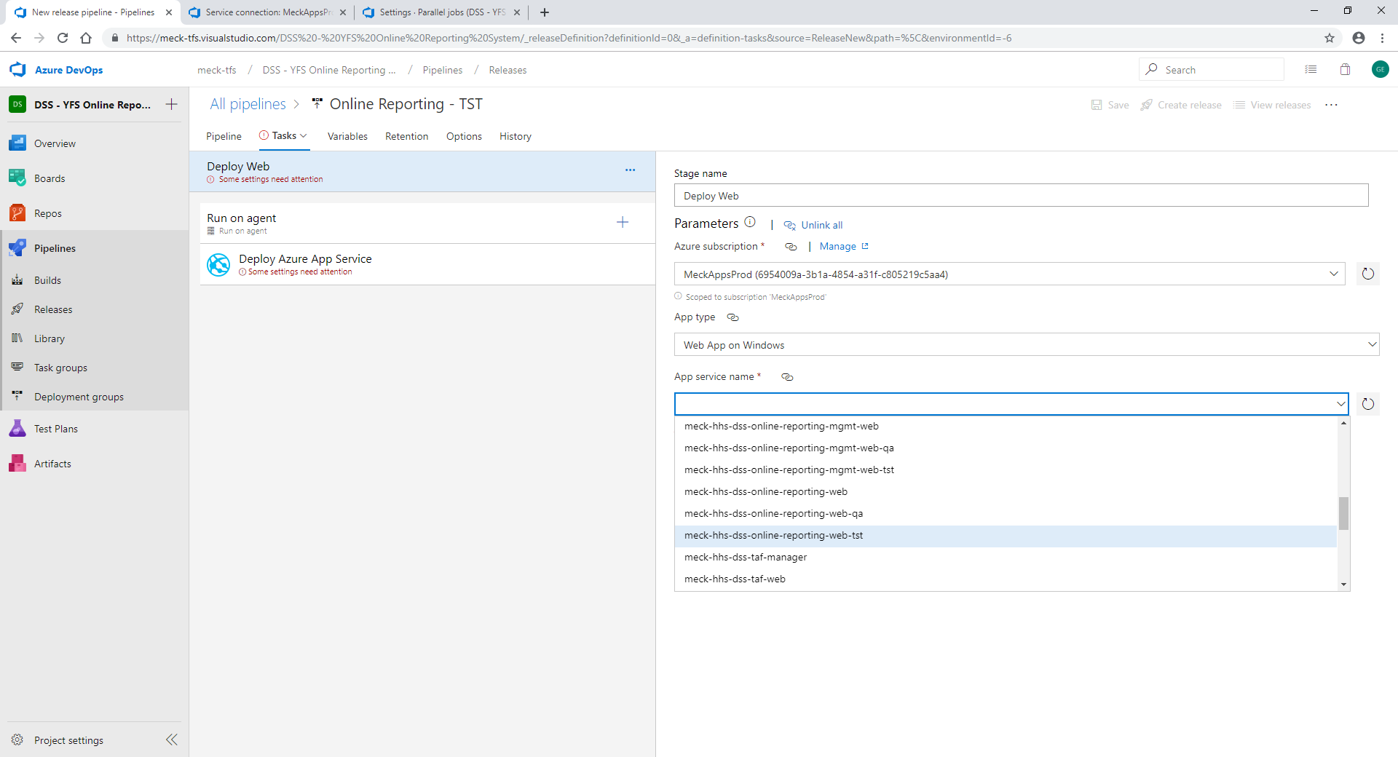

1. **Select ‘**Run on agent’ step.

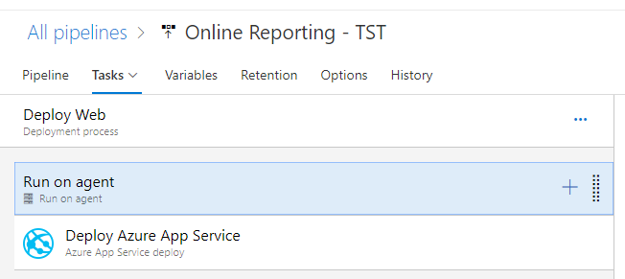

1. You should not have to change anything on this screen. It should look like the image below.

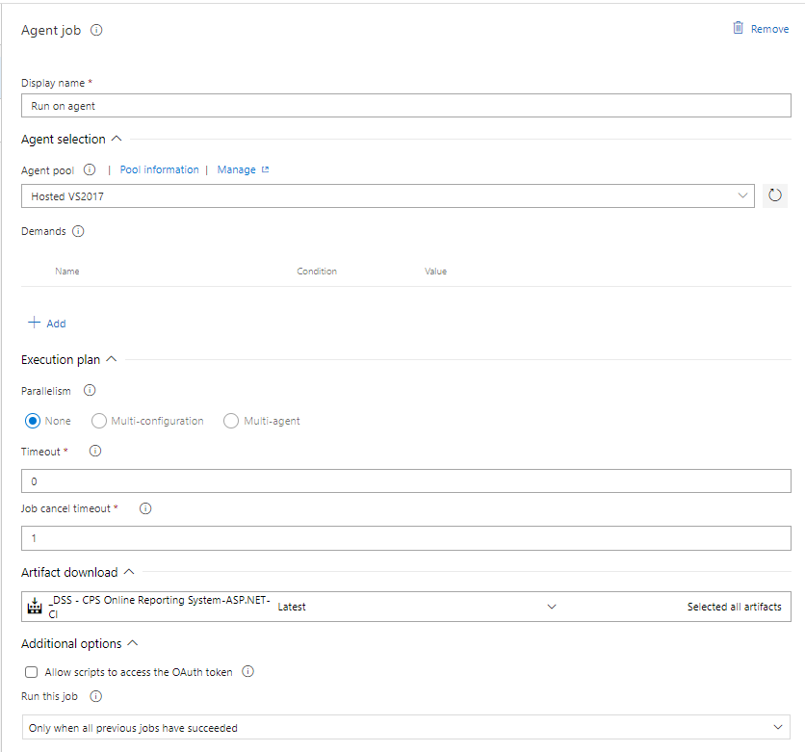

1. **Select** ‘Deploy Azure App Service’ step.
2. **Change** the ‘Package or folder’ field to match the zip name of the artifact you want to deploy.

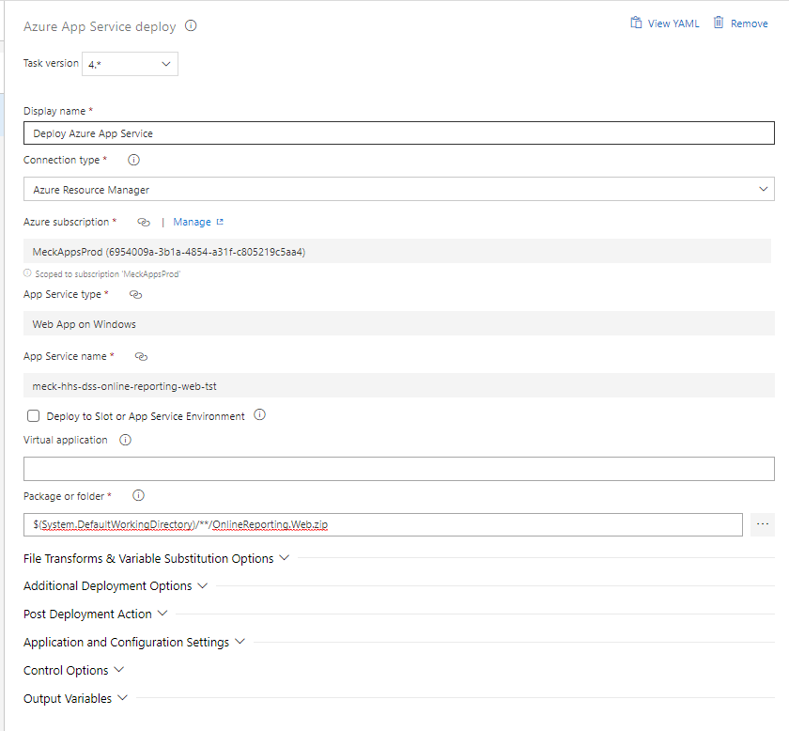

1. **Click** ‘Save’

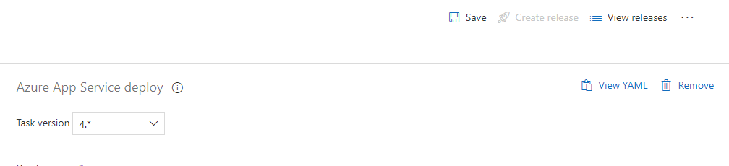

Configure Web API Deployment

1. **Click** ‘Pipeline’
2. **Select** ‘Deploy Web’
3. **Highlight** files icon
4. **Click** Clone

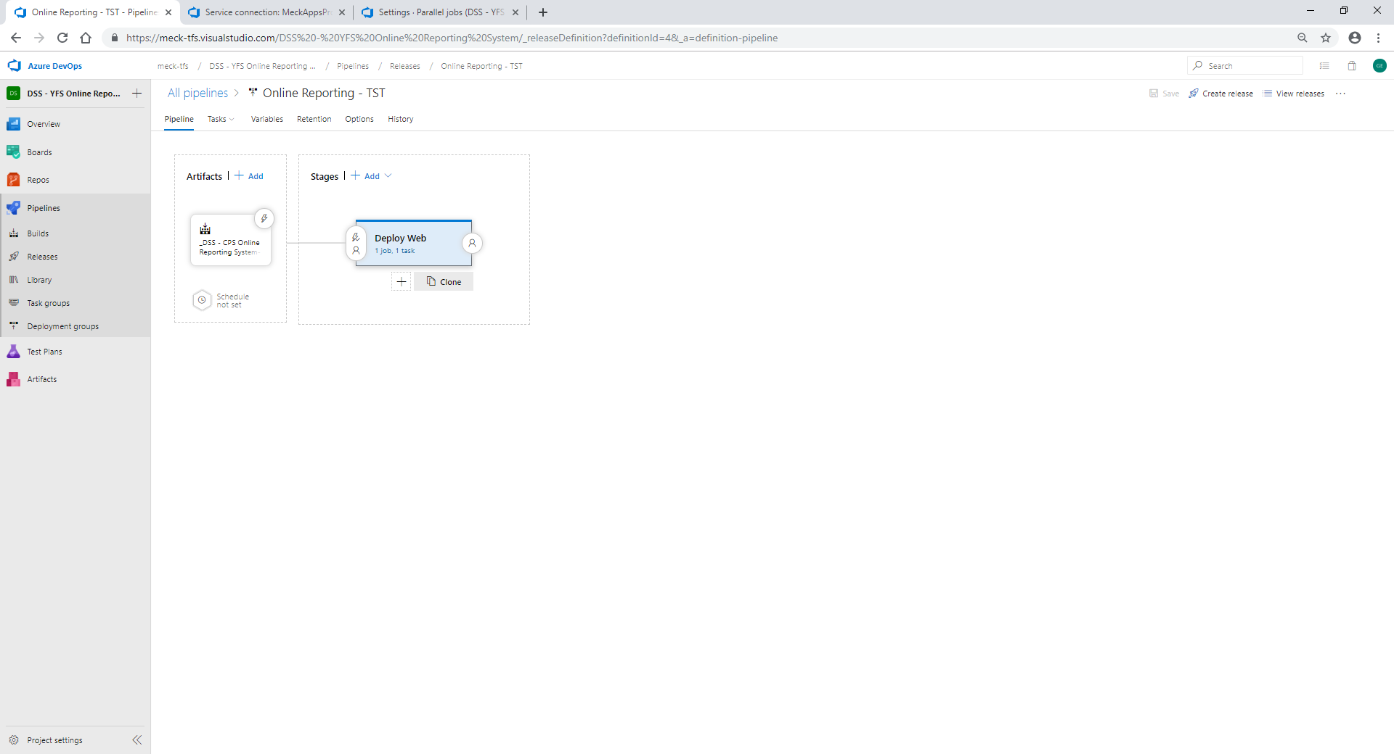

1. **Click** on the Copy of Deploy Web link ‘1 job, 1 task’
2. **Change** the stage name ‘Deploy Manager‘

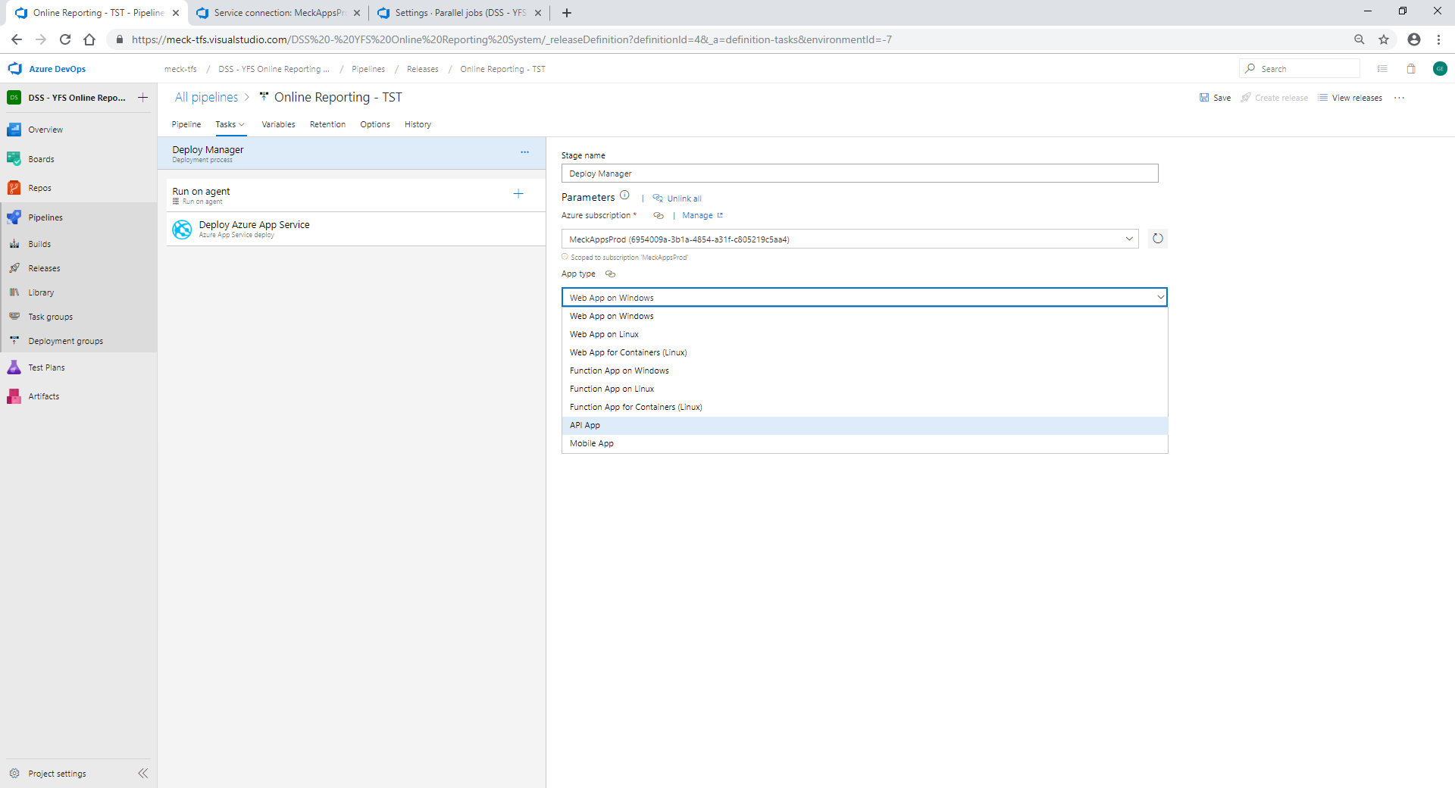

1. **Select** App type of ‘API APP’
2. **Select** App service name (Should the web app resource you are deploying to)

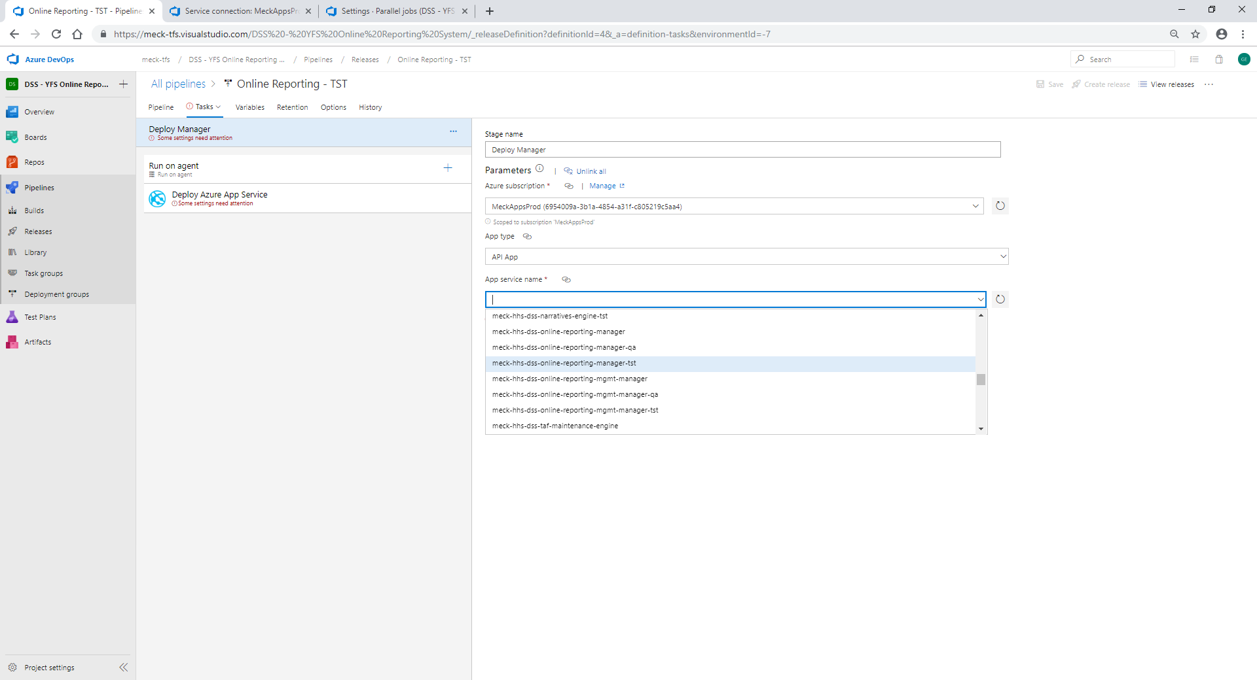

1. **Select** ‘Deploy Azure App Service’

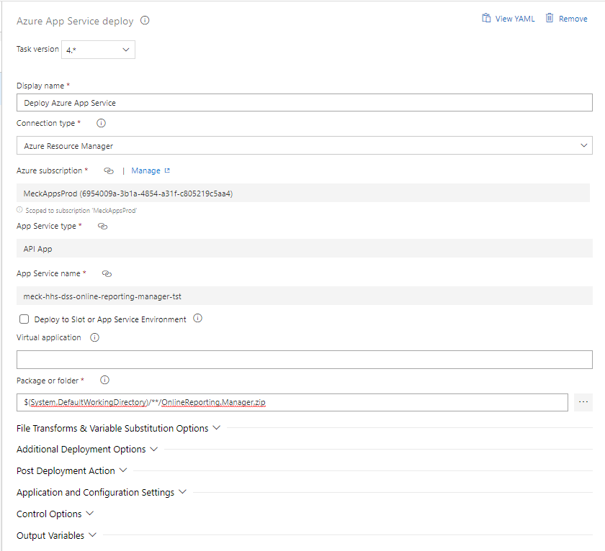

1. **Change** the ‘Package or folder’ field to match the zip name of the artifact you want to deploy.
2. **Click** ‘Save’



Manually Run Release

1. **Click** ‘Create release’ top right of the screen



1. **Select** the release version you wish to deploy

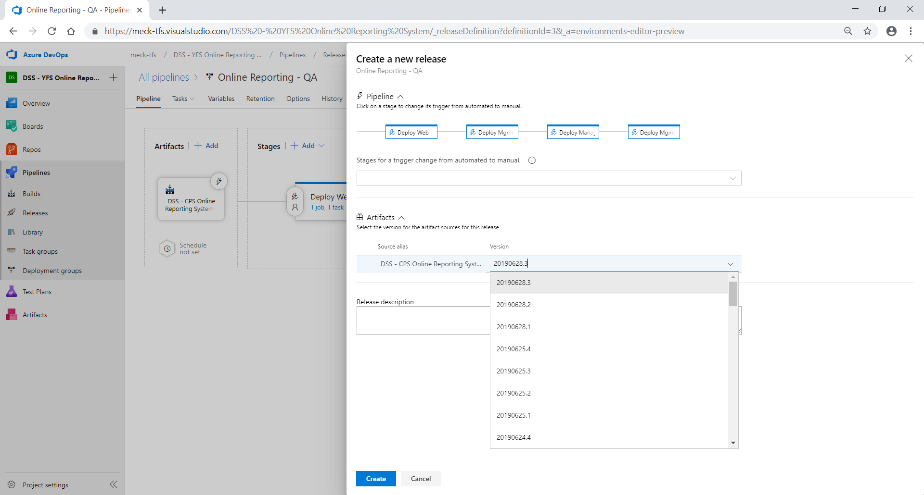

1. **Click** ‘Create’
2. **Click** Release link to see progress of deployment

